To Boulder Town Planning Commission, Boulder Town Council & Boulder Town Residents
Committee Chairwoman, Commissioner, Mayor, Council Members and Residents
August 28, 2020

My name is Debra Oldham. My husband and I have a home located across the street from the proposed subdivision on Burr Trail Road. We live on a parcel of land that includes the Thompson Ledge. My father was a rancher on this land and this was my first home. My grandfather also had a ranch in Boulder where he raised eight children. His parents were among the first settlers that came to this valley. The Hale Center Theatre created a play about my grandmother’s life in Boulder. My parents are buried in the Boulder cemetery.

My brother and I are working on creating attractive homes on the parcel of land we own together with our sister. It’s proving to be a lot of work and more expensive than anticipated. But we’re devoting a good portion of our resources to this work.

I’m including this information about my family because I want you to understand that although we have not spent millions of dollars to be here, we are just as invested in this town as those who have. I care about Boulder deeply and what the town represents. The Peterson family has had offers to sell the property. We could cash out and be set up for life. We choose not to make a money grab because we love Boulder. We prove it by making upgrades to the property. We prove it by allowing the Town and Garfield County to place radio and TV towers on our property which have benefited the Town of Boulder for many years. We have been careful to do everything in accordance with Boulder Town’s ordinances and have never asked for any special consideration or changes to suit our personal needs.

From the well-orchestrated presentation at the Planning Commission Meeting on Aug. 13th, it was obvious that some ‘targeted’ people had been prompted by the developers to write letters in support of allowing a high-density subdivision with the hope of creating affordable housing. It was also obvious that those of us who would be most directly and immediately impacted by this plan were not given the same consideration.

The purpose of this letter is to express my concerns regarding the proposed subdivision. I am not doubting the need for ‘affordable’ housing in Boulder, and perhaps it is time to consider creating a subdivision with some lots smaller than five acres. But this beautiful, productive pasture, surrounded by wetlands, and highly visible from many of Boulder’s main roads is the NOT right place.

Outlining the numerous ways this subdivision conflicts with the Town’s General Plan and Vision Statement, would make for a lengthy document. For the sake of brevity, I will only address a few of my major concerns.

- Please consider the ramifications of 12 new septic systems installed above and bordering on a wetlands drainage area; which then drains directly into our property. What measures could be taken to prevent contamination of the wetlands area and neighboring properties? I see potential for serious health and safety issues. I am particularly concerned about the contamination reaching our well-water.

- It is becoming apparent that affordable housing is a promise that has not been backed up with any sort of details. What will be the final cost of the houses within the subdivision? Let’s move from PR and broad generalities to specific details to determine if it is in fact affordable. This is not an inexpensive piece of land. Only a fraction of it can be used for building, plus there will be many additional expenses because of wetland mitigation measures and site work, including roads, pipelines, etc. This issue warrants further evaluation.

- Visual impact:

This picture shown on Town of Boulder website is one of the most attractive areas in the State of Utah. I watch as visitors walking or driving along Burr Trail Road routinely stop to photograph this area and have often engaged in conversations on the natural beauty of this place.

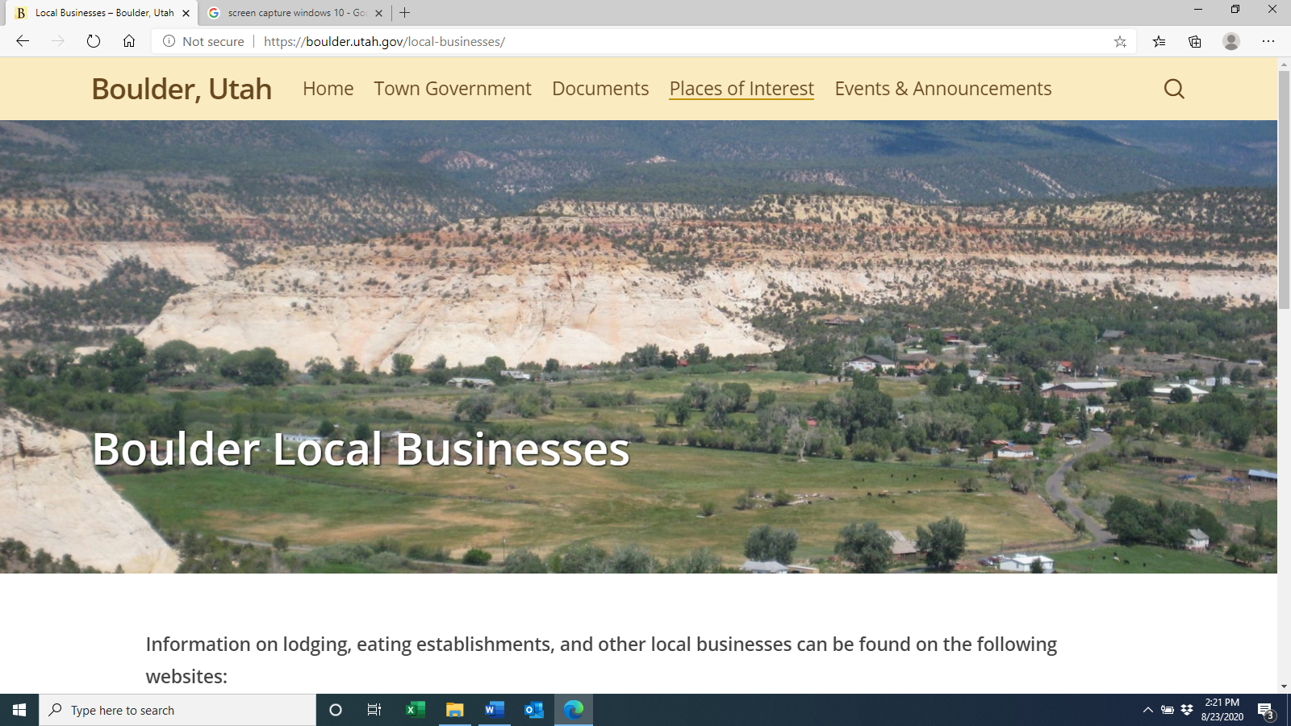

The developer has painted a lovely picture of a nice little cluster of homes. But let’s considered the reality of this picture in the future. There will most certainly be years of construction. There is no real plan for the actual structures that may be built there. The concept plan calls for “self-build opportunities”. In the concept plan the developer states “This is one of the few remaining examples of the agricultural heritage in the Town center area and this plan will preserve the most highly visible portion of the site”. I would submit that the cluster of homes at the highest point of the site would then become the focal point. The strip of land between the road and the homes referred to as “irrigated open space” would fade into the foreground.

The beauty of places such as the Grand Staircase-Escalante are protected by the Federal Government. The only body protecting the Town of Boulder is the Town of Boulder.

Growth and change are vital to the future well-being of a town. This town, however, has limited growth potential with the current infrastructure. Any changes need to be very carefully considered before they are implemented.

In closing, I would plead with the Town Planning Commission and the Boulder Town Council to stay the course. We have a vision for the future of this town. It is clearly laid out in our General Plan and Vision Statement. Do not allow good salesmanship to adversely alter the future of our town.

Sincerely,

Debra Oldham
280 E Burr Trail Rd., Boulder
Local phone: (435) 335-7996
Cell Phone: (801) 310-3074
Email: adoldham76@gmail.com

