Boulder Town Engineering and Infrastructure Standards V1.0
Adopted DD/MM/2024
Draft 06/26/24

Table Of Contents
Boulder Infrastructure Design Standards V1.0 Adopted DD/MM/2024 1
Table Of Contents 1
Purpose and Applicability 3
Introduction 3
Design Alternatives 3
Exclusions 3
Adoption by the Town 4
Private Road Cross Section 5
Fire equipment turnaround 6
Geometric layout of intersection of private road with public road. 7
Drainage plan requirements. 8
Culvert for crossing dry wash or drainage channel 8
Other Infrastructure 9
Potable Water 9
Sanitation 9
Electricity 9
Communications 9
Irrigation Infrastructure 9
Assumptions for Plat Review 9
Subdivision Design Requirements 9
Requirements for roads crossing irrigation canals or ditches 10
Quantitative Engineering Design Criteria 11
Drainage 11
Rainfall 11
Subdivision Roads 11
Existing drainage channels 11
Traffic Design 12
Current Boulder Traffic 12
ADT data for 2020 12
Rule of Thumb Guidance 12

Purpose and Applicability

Introduction
This document shall be officially named the "Boulder Town Infrastructure Design Standards - Version ##, Dated DD/MM/YYYY." The short name for repeated mention is "current design standards".
These design standards are intended describe the Town's minimum subdivision infrastructure requirements to provide guidance for property owners when preparing subdivision applications and for the Administrative Land Use Authority when evaluating applications. The standards address municipal concerns including public health and safety, emergency vehicle access, and protection of existing infrastructure and adjacent property. The changes in Utah Municipal Code due to SB174 (2023) require that subdivision approval be an administrative act based on cited codes and standards. Discretionary language stating "as approved by the Town" or similar needs to be replaced by clear language as to what is required or prohibited.
Boulder Town wishes to preserve the current rural character and avoid typical suburban-style development. The town also desires to promote housing affordability by simplifying the subdivision process for do-it-yourself development of single lots.
These standards do not require the level of development that may be expected by all buyers. Providing subdivision infrastructure exceeding these standards is a private matter between the developer and the buyer.

Design Alternatives
These standards prescribe a basic design that can be used as guidance by citizens who are undertaking "do-it-yourself" creation of a small number of lots. Alternative subdivision infrastructure designs that prepared by a licensed professional engineer and are based on nationally recognized codes will be considered acceptable by Boulder Town.

Exclusions
The standards assume residential and cottage industry development of parcels with typical local terrain conditions, but are not applicable to the following:
1) Subdivisions intended to ultimately create more than 25 lots.
2) Subdivisions intended to allow commercial development involving customer traffic or industrial activity.
3) Development in the "Sensitive Lands, Hillside, and Mesa Tops Protection Overlay District. This exclusion does not apply to any portion of the subdivision that is indicated on the plat as being permanently designated for agriculture or open space.
4) Subdivision access across perennial streams (Boulder Creek, West Fork of Deer Creek).
Engineering design is required for roads and other infrastructure of subdivisions that are excluded from the scope of these standards.

Adoption by the Town
It is intended that these standards by referenced in the Land Use Code where appropriate and that each revision be adopted by Town Council resolution.
Resolution YYYY-##
The Boulder Town Council hereby resolves that the Boulder Town Infrastructure Design Standards - Version ##, Dated DD/MM/YYYY as posted on the town website is the current reference document.
Passed: DD/MM/YYYY
Attest: _________, Town Clerk

Private Road Cross Section
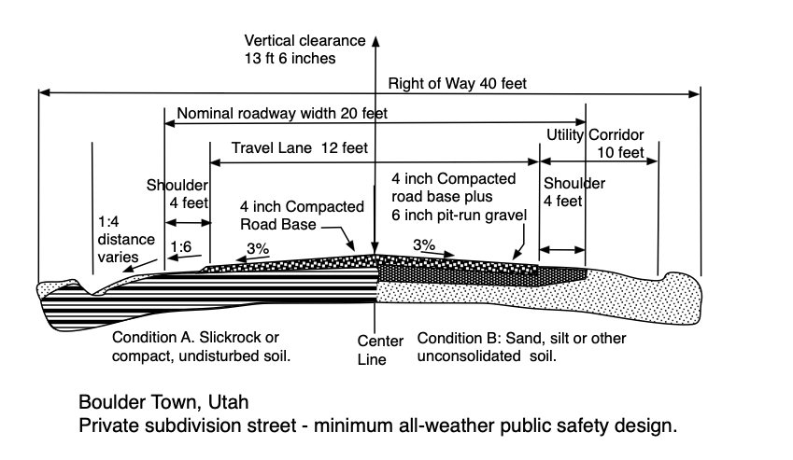

Editable File: Road Section V2 P626.ezdraw

Fire equipment turnaround

Emergency Access notes:
1. Fire apparatus access road configuration shall meet the intent of International Fire Code section Section 503 and Appendix D including Figure D103.1 for turnarounds on dead-end roads in excess of 150 ft .
2. Per IFC Section 503.2.4 Turning radius the required Turning radius of a fire apparatus access road shall be determined by the fire code authority.
3. A turnaround with 20 ft. inside radius and 40 ft outside radius is adequate for Boulder Town fire trucks per Boulder Town Fire Authority Pete Benson in 2024.
4. Maximum grade of a fire access road shall be 10% or as approved by the code official. NOTE FOR PETE BENSON: Given that Highway 24 reaches 14% grade and considering Boulder fire equipment would you agree with 14% for distances less that 100 feet?
5. Design by a professional engineer is required if terrain constraints require modification of the default IFC access standards.

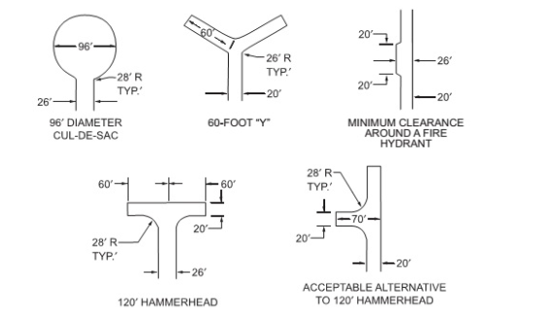
Turnouts shall be provided when a single-lane fire access road exceeds 400 feet in length.
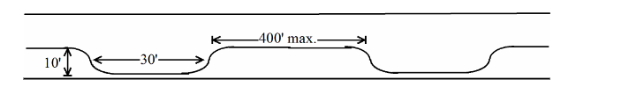

Geometric layout of intersection of private road with public road.

Pending -

Drainage plan requirements.
Applicability - these default drainage requirements apply only to subdivisions on normal Boulder sandy soils and not receiving direct runoff from areas of slickrock larger than 10 acres.

Culvert for crossing dry wash or drainage channel

1. Provide culverts where crossing existing natural drainages and roadside ditches.
2. Minor natural drainages may be combined via roadside ditches on uphill side.
3. Minimum culvert diameter 18 inches for drainages handling only on-site rainwater.
4. Minimum culvert diameter 24 inches for drainages handling off-site flows.
5. Minimum compacted fill over culvert 6 inches.
6. Engineered design required for drainage along roads crossing side slopes greater than 15 degrees for a distance greater than 50 feet.
7. Engineered design required for roads crossing Boulder Creek and West Fork of Deer Creek.
8. Engineered design is required for drainage if proposed house building footprint is in a mapped floodplain or designated wetland.

Irrigation notes.
1. Irrigation ditch crossings require design approval by the irrigation company.

Other Infrastructure

Potable Water
Proof of potable water is required options are:
1) A binding contract with a public water company regulated by the State of Utah to supply culinary water. An application to Boulder Farmstead is not sufficient; the application must be approved.
2) An underground water right granted by the State of Utah to drill a well. State approval of the well application is sufficient. Drilling of the well and proving the water right can take place after subdivision. Prompt development of the water right is prudent because the water application approval is for a limited time and rules can change.

Sanitation
Septic systems are regulated by Southwest Utah Public Health Department. Each lot required identification of an approved septic system location.

Electricity
Off-grid solar power is permitted.

Communications
Boulder has no requirements for phone or internet connection in subdivisions.

Irrigation Infrastructure

Assumptions for Plat Review
All existing irrigation ponds, canals, ditches, diversion structures, and pipelines are private property owned either by the Boulder Irrigation Company or by downstream water users.
Existing irrigation structures may have an easement created by historic use even if the easement has not been recorded.
Good faith negotiation between the developer and the irrigation company is encouraged, but is regarded as a private matter by the town.

Subdivision Design Requirements
Location of all known irrigation infrastructure shall be shown on the subdivision plat.
Written approval of Boulder Irrigation Company is a recommended part of the application for any subdivision and is required if the subdivision construction disturbs or alters existing irrigation infrastructure.
Recommended good practice is that the plat indicate a 30-feet wide access easement (15 feet on each side of centerline) for irrigation company maintenance of existing canals, ditches, and pipelines within the subdivision.
Subdivision applications requesting credits or incentives for agricultural protection must provide documentation of the necessary transfer of water rights.

Requirements for roads crossing irrigation canals or ditches
A metal or plastic culvert shall be provided where the road crosses the canal.
Culvert diameter shall be 36 inches or as determined by the irrigation company.
Compacted road base thickness over the culvert shall be 12 inches or as specified on the culvert manufacturer's design table.
Stone riprap or a concrete headwall and wingwalls shall be provided on the upstream side.

Quantitative Engineering Design Criteria
The following Boulder-specific design criteria are provided for reference by citizens, design professionals, and the administrative land use authority in preparing and reviewing subdivision infrastructure proposals.
These criteria reflect past Boulder practice and may be less restrictive than criteria used in other jurisdictions or criteria found in codes that have not been formally adopted by the Town.

Drainage

Rainfall
Point precipitation frequency estimates for Boulder, UT taken from the NOAA website.
Duration | 10-year | 25-year | 50-year | 100-year
1-hour | 0.87 inches | 1.15 inches | 1.40 inches | 1.69 inches
24-hour | 1.99 inches | 2.44 inches | 2.80 inches | 3.18 inches
Note: These values are for 300 North and Highway 12. Precipitation is much higher at the north end of town closer to Boulder Mountain.

Subdivision Roads
The design criterion for private roads in small subdivisions is that the driving surface should not wash out during a 25-year storm event. Minor, temporary flooding of a paved or hardened swale is consistent with the rural character of Boulder.

Existing drainage channels
Subdivision roads crossing existing drainage channels shall not cause the storm runoff to leave the channel and flood adjacent property.

Traffic Design
Consistent with the rural character of Boulder new subdivision roads should be designed as informal "country lanes" with low design speed.

Current Boulder Traffic
ADT data for 2020 (Jones & Demille, 2022)
Highway 12: 760 Vehicles per day
Burr Trail: 540 Vehicles per day

Rule of Thumb Guidance
(website MikeOnTraffic.com)
Single family house: 10 trips per day, 1 per peak hour.
Planning level for local 2-lane street based on livability: 1000 vehicles per day
Capacity for 2-lane street with left turn lanes: 18,300 vehicles per day.

Quantitative Design Attributes
The following design criteria are descriptive of past practice in Boulder. Values are based on the Utah Wildland-Urban interface code, DOCUMENT, and the Garfield County, Washington road standards.
Design Attribute | Driveway | Private Subdivision Road | Road intended to be dedicated to the town | Note
Lots accessed | 1 lot Maximum  Max 2 buildings not including accessory structures | 1 to 25 | Unlimited
Design speed | NA | 15 mph | 25 mph
Lanes | 1 | 1 with passing turnouts | 2
Lane width - driving surface | 10 ft | 12 ft | 12 feet x 2
Shoulder | 5 ft | 4 ft | 4 ft
Width clear for emergency vehicles | 20 ft | 20 ft | 32 ft | WUIC minimum 20 ft
Vertical Clearance | 13 ft 6 inches | 13 ft 6 inches | 16 ft | WUIC  13'-6"
Passing turnout interval | 200 ft | 200 ft | NA
Passing turnout length | 30 ft | 30 ft | NA
Passing turnout width | 8 ft | 8 ft | NA
Dead-end turnaround | Per Fire Code | Per Fire Code | Per Fire Code | WUIC and IFC
Recorded right of way width | NA | 40 ft | 66 ft
Cross Slope | NA | 3% | 3%
Radius of curvature | NA | 200 ft or right angle intersection | 200 ft or right angle intersection

