**Resolution 2024-X**

**Adoption of the Boulder Town Infrastructure Design Standards**

**Whereas** the Boulder Town Planning Commission has revised and forwarded to the Boulder Town Council Ordinance 2024-A, that repeals the current Subdivision Chapter (152) of the Boulder Town code and replaces it with new code; and

**Whereas** in the process of developing the revised Subdivision Chapter, the Planning Commission was advised by Town Council members to develop a set of standards that would apply to requirements outlined in the Subdivision Chapter; and

**Whereas** these Infrastructure Design Standards are intended to establish objective criteria that: 1) provide applicants with example designs to help them understand town expectations when preparing applications, 2) provide guidance and criteria for review by the Administrative Land Use Authority of subdivision applications, and 3) describe and quantify minimum design criteria that are considered necessary to protect town interests; and

**Whereas** the attached “Standards” document outlines guidelines and examples to be used by any applicant proposing a subdivision;

**Now therefore**, be it resolved that the Boulder Town Council adopts the Boulder Town Infrastructure Design Standards, Version 1.1, Dated DD/MM/2024.

Passed: DD/MM/YYYY

Attest: _________, Town Clerk

Attest: _________, Mayor

# 

**BOULDER TOWN INFRASTRUCTURE DESIGN STANDARDS**

**VERSION 1.1**

**DRAFT 11/10/24**

Contents

***Section 1 – Purpose and Applicability 5***

**Introduction 5**

**Design Alternatives 5**

**Disclaimer 5**

**Exclusions 5**

**Definitions 6**

***Section 2 - Subdivision Improvement Plan 7***

**General Requirements 7**

***Section 3 – Access and Easements 9***

**Requirements for Recorded Access 9**

**Requirements for New Platted Access 9**

**Requirements for New Easements 9**

***Section 4 - Driveways, Private Roads, and Public Roads 10***

**Basis for Standards 10**

**Cross Section of Private Road Meeting WUIC All-Weather Road Requirements 10**

**Fire Equipment Turnaround 11**

**Design for Intersection of Private Road with Public Road 12**

Applicability 12

Intersection with Highway 12 12

Intersection with Town Roads 12

Geometric design 12

Sign Requirements 12

**Design Criteria for Subdivision Roads to Be Dedicated to Boulder Town 12**

***Section 5 - Guidance for Proposed Maintenance of Private Subdivision Roads 14***

***Section 6 - Public Safety 15***

**Fire Protection Plan 15**

Requirements for Preliminary Subdivision Applications 15

General Requirements 15

Fire Access Roads 15

Other Requirements 15

***Section 7 - Stormwater Drainage, Flood Plains, Sensitive Lands, and Natural Hazards 16***

**Stormwater Drainage Plan. 16**

Default Plan – Subdivisions Disturbing Less Than 1 Acre 16

Subdivisions Disturbing More Than 1 Acre 16

**Flood Plains and Wetlands 17**

**Sensitive Lands 17**

**Natural Hazards 17**

***Section 8 - Other Subdivision Development Infrastructure 18***

**Potable Water 18**

**Wastewater Disposal 18**

**Electricity 18**

**Communications 18**

**Irrigation Infrastructure 18**

Subdivision Application Requirements 18

Irrigation In or Crossing Subdivision 19

Assumptions for Plat Review 19

Roads Crossing Irrigation Canals or Ditches 19

***Section 9 - Open Space & Agricultural Protection 20***

**Non-Buildable Lots associated with Lot Averaging 20**

***Section 10 - Quantitative Engineering Design Criteria 21***

**Garfield County Climatic and Geographic Design Criteria 21**

**Drainage 21**

Rainfall 21

Drainage criteria for subdivision roads 21

**Local Traffic Data 21**

Current Boulder Traffic 21

ADT data for 2020 21

Traffic Design 22

**Quantitative Road Design Attributes 22**

# Section 1 – Purpose and Applicability

## Introduction

These standards are an attempt to document current practice, not to make new rules. The purpose of the standards is to establish objective criteria to 1) provide applicants with example designs to help them understand town expectations when preparing applications, 2) provide guidance and criteria for review of subdivision applications by the Administrative Land Use Authority (ALUA), and 3) describe and quantify minimums considered necessary to protect town interests.

This document is advisory guidance based on normal practice at a typical site in Boulder. These design standards are intended to describe the Town's minimum subdivision infrastructure requirements The standards address municipal concerns including public health and safety, emergency vehicle access, and protection of existing infrastructure and adjacent property. The Town does not guarantee that the infrastructure described in these standards will be suitable or adequate as the construction design for any specific project. Applicants are encouraged to consult qualified professionals regarding subdivision development.

The changes in Utah Municipal Code due to SB174 (2023) require that subdivision approval be an administrative act based on cited codes and standards. The Subdivision Ordinance, Chapter 152, has been revised to replace discretionary "as approved by the Town" or similar language with objective statements regarding what is required or prohibited. The purpose of these standards is to supplement the ordinance with sample drawings and design criteria statements to provide guidance for property owners when preparing subdivision applications and for the ALUA to apply when evaluating applications.

These standards do not address design and infrastructure features related to the market appeal and long-term operation and maintenance of a subdivision. These standards do not require the level of development that is typically associated with traditional suburban subdivisions or the expectations of some buyers. Developing subdivision infrastructure exceeding the minimum requirements of these standards is a private matter between the developer and the buyer.

## Design Alternatives

These standards prescribe a basic design that can be used as guidance by citizens who are undertaking "do-it-yourself" creation of a small number of lots. Alternative subdivision infrastructure designs that are certified by a licensed Professional Engineer or Surveyor and are based on nationally recognized codes and accepted good practice will be considered approvable by the ALUA.

## Disclaimer

These standards are intended to provide criteria for Boulder Town review of subdivision applications and are not a substitute for the applicant's responsibility to obtain appropriate professional assistance from licensed surveyors, attorneys, engineers, or construction contractors as needed.

## Exclusions

These standards assume residential and cottage industry development of parcels with typical local terrain conditions, but are not applicable to the following:

1) Subdivisions intended to ultimately create more than 20 lots.

2) New lots intended to allow commercial development that exceeds *de minimus* customer traffic or ongoing outdoor industrial activity.

3) Subdivision that takes place in the "Sensitive Lands, Hillside, and Mesa Tops Protection Overlay District unless the portion of the subdivision in the overlay district area is indicated on the plat as being permanently designated for agriculture or open space.

4) Subdivisions that involve access across perennial streams (Boulder Creek, West Fork of Deer Creek).

Other more narrow exclusions appear as part of the detailed standards.

## Definitions

**Code**, **applicable** - The published and adopted fire and construction codes applicable to the item being discussed. See Chapter 151 for the specific codes adopted by the Town and UCA Title 15 A for the current list of code editions adopted by the state.

**Ordinance (or Town Ordinances)** - The current codified version of the Boulder Town Code as posted on American Legal.

**Town** - Boulder, Utah

**WUIC** - Utah Wildland-Urban Interface Code

# Section 2 - Subdivision Improvement Plan

*Authority 152.501; Definitions and review requirements in Utah Code.*

## General Requirements

1) Subdivision Improvement Plans consisting of the necessary construction drawings and specifications are required for all required subdivision infrastructure except when an exemption in the Chapter applies.

2) Boulder requires submission of the subdivision improvement plans after Preliminary Approval and as part of the Final Subdivision Application.

3) Boulder ALUA plan review is limited to verifying compliance with the subdivision and zoning ordinance requirements.

4) The developer, consultants, and contractors hired by the developer are responsible for all design decisions and for compliance with good practice and applicable codes.

| **Required Infrastructure** | **Minimum documentation with application shall describe the following:** |
| --- | --- |
| Access from a public road to each lot | Layout shown on plat  Legal right to construct and maintain  Construction drawings with layout dimensions and road cross section details. |
| Private road maintenance agreement | Agreement that town has right to maintain emergency access.  Document binding on future lot buyers meeting the provisions of the Boulder Standards |
| Potable water | Signed contract with a public water company OR  Approved right to drill a well. |
| Wastewater disposal  Note 1 | Approval for a septic system on each lot from Southwest Public Health OR  Engineered system approved by the state or local health authority |
| Fire protection plan  Note 2 | Approval letter from the Boulder Fire Authority  Fire lane and turnarounds as approved by the fire authority shown on plat or other construction drawing,  Water storage and distribution construction drawings for the supply as approved by the fire authority.  Construction drawings for any other fixed fire protection infrastructure required by the fire authority. |
| Stormwater drainage | Required ditches and culverts included on road drawings. |
| Other Utilities  Note 3 | Agreement that future power and communication utilities will be underground. |
| Irrigation water | Approval from Boulder Irrigation Company for any new or changed infrastructure. |
| Conservation and open space | Signed agreement and recorded deed restrictions based on approved conditions. Applicable only if proposed by applicant in exchange for incentives. |

Note 1) Approved perc test on each lot is sufficient to demonstrate feasibility of wastewater disposal. Actual location of the tank and drain field is normally determined at the time of dwelling construction.

Note 2) Both the International Fire Code and the Utah Wildland - Urban Interface Code involve fire protection requirements that depend on building use, size, and type of construction. These aspects of the fire protection plan need to be determined at the time of building permit application.

Note 3) Road dust and erosion control, electricity, telephone, internet, and heating fuel are all expectations for a dwelling lot but are not regulated by Boulder Town. These are a private matter between the developer, the utility supplier, and the buyers.

# Section 3 – Access and Easements

*Authority: 152.401*

## Requirements for Recorded Access

Minimum standards for ALUA approval of proposed access:

1) These requirements apply both within the subdivision and to any land that must be crossed outside the subdivision to provide access from a proposed lot to a public road.

2) The plat shall show the access from each lot to a public road.

3) Existing easements that will be used for access to the subdivision shall be fully documented. The subdivision plat shall cite the recorded deed or plat that documents all existing easements that are being relied on by the subdivision. The cited documents shall be included in the Preliminary Subdivision Application.

4) Minimum width for an easement serving a subdivision lot is 40 ft to allow for road construction or upgrading, long-term maintenance, snow storage and stormwater drainage, potential utility infrastructure, and passing turnouts on a fire lane meeting Wildland-Urban Interface Code

5) Documents amending existing or historic easements shall be recorded concurrent with the final plat.

## Requirements for New Platted Access

1) Flag lots are permitted as a means of access to a lot not fronting on a public road. The minimum width of the "pole" shall be 40 feet.

2) Demarking a tract of land for a private street for the common use of adjacent lot owners is encouraged.

3) Arranging lots around a cul-de-sac is an acceptable form of frontage and access.

4) If a platted private street serves more than two lots a covenant or deed restriction shall be recorded documenting arrangements for ownership and maintenance.

## Requirements for New Easements

1) All new access easements created as part of the subdivision development process shall run with the land, allow maintenance by the beneficiaries, and allow full use for all customary residential or agricultural purposes.

2) New easements shall explicitly identify the beneficiaries (owners of lots ##, owners of adjacent property, retained rights by the seller); and a covenant or deed restriction shall be recorded documenting arrangements for easement ownership and maintenance.

3) Formation of a Homeowner’s Association to handle ongoing maintenance is encouraged.

# Section 4 - Driveways, Private Roads, and Public Roads

*Authority: 152.503*

## Basis for Standards

Boulder Town has a public safety interest in making sure that all subdivision lots can be accessed by emergency vehicles including a fire truck, ambulance, and sheriff. Fire access must meet the intent of the Utah Wildland-Urban Interface Code as interpreted by the local Fire Authority. Most property owners will want a road that is adequate for delivery trucks and passenger cars either seasonally or year around.

The road construction cross section shown below and on the following pages is based on what has been built by local contractors in Boulder and has proven to be durable for light traffic, requiring only periodic regrading and control of encroaching vegetation.

A Subdivision Improvement Plan proposing driveway or road construction based on these standards will be presumed to meet ordinance requirements.

## Cross Section of Private Road Meeting WUIC All-Weather Road Requirements

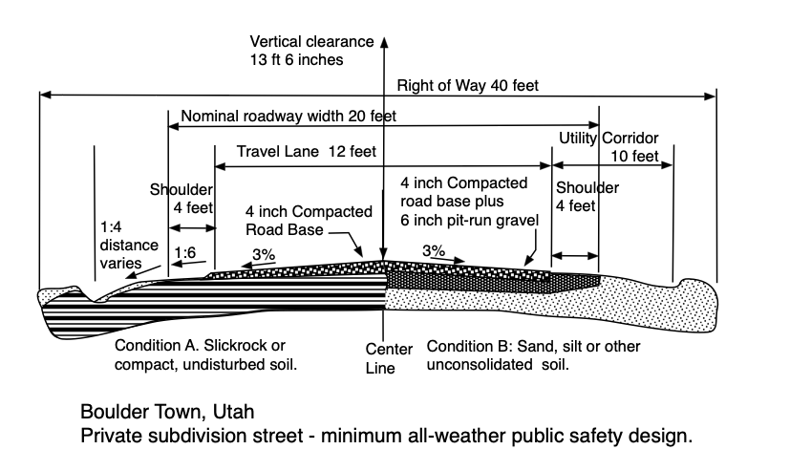

Note: The entire nominal roadway width shall be kept free of trees, brush, flammable debris and any similar obstruction to emergency vehicle travel. The shoulder on narrow travel lanes shall be sufficiently compact native soil or fill adequate to support emergency vehicle passing. Mowed vegetation that stabilizes the soil is acceptable.

## Fire Equipment Turnaround

Emergency Access notes:

1. Fire apparatus access road configuration shall meet the intent of International Fire Code section Section 503 and Appendix D including Figure D103.1 for turnarounds on dead-end roads in excess of 150 ft .

2. Per IFC Section 503.2.4 The required turning radius of a fire apparatus access road shall be determined by the fire code authority.

3. A turnaround with 20 ft. inside radius and 40 ft outside radius is adequate for Boulder Town fire trucks per Boulder Town Fire Authority Pete Benson in 2024.

4. Maximum grade of a fire access road shall be 10% or as approved by the code official. NOTE FOR PETE BENSON: Given that Highway 24 reaches 14% grade and considering Boulder fire equipment would you agree with 14% for distances less that 300 feet?

5. Design by a professional engineer is required if terrain constraints require modification of the default IFC access standards.

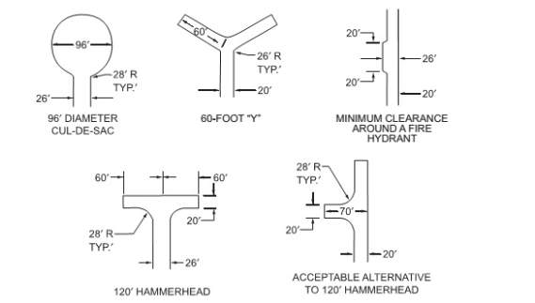

Turnouts shall be provided when a single-lane fire access road exceeds 400 feet in length.

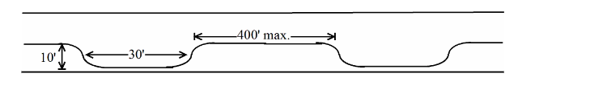

## Design for Intersection of Private Road with Public Road

### Applicability

This standard applies to new or substantially modified subdivision private roads and driveways. It also applies to new driveways proposed when applying for a building permit on an existing lot.

### Intersection with Highway 12

Utah Department of Transportation rules and standards apply to any new access to Highway 12. A copy of the UDOT application shall be included with the Preliminary Application and documentation of UDOT approval shall be included with the Final Subdivision Application.

### Intersection with Town Roads

The following requirements apply to intersections with town roads.

1) Intersection at a 90 degree angle is preferred, but may be between 70 and 110 degrees.

2) Continued use of historic wye-type intersections is allowed.

3) Any gate shall be set back 20 feet from the public road to allow parking when opening or closing the gate.

4) A stop sign and street number sign meeting town specifications shall be provided at the intersection.

### Geometric design

Geometric design shall be in accordance with the attached Drawing ###.

Reference Data

https://iowadot.gov/design/dmanual/06a-01.pdf

https://dotfiles.sd.gov/rd/preface-rd.pdf

https://safety.fhwa.dot.gov/local_rural/training/fhwasa1108/ch3.cfm

### Sign Requirements

Pending - Specification based on current signs

Standard UDOT stop sign

Street sign Dimensions, lettering size.

(Note: most towns use green for public roads, blue for private roads).

## Design Criteria for Subdivision Roads to Be Dedicated to Boulder Town

Section Reserved

At this time the Boulder Town Council is not accepting new roads for dedication as public roads.

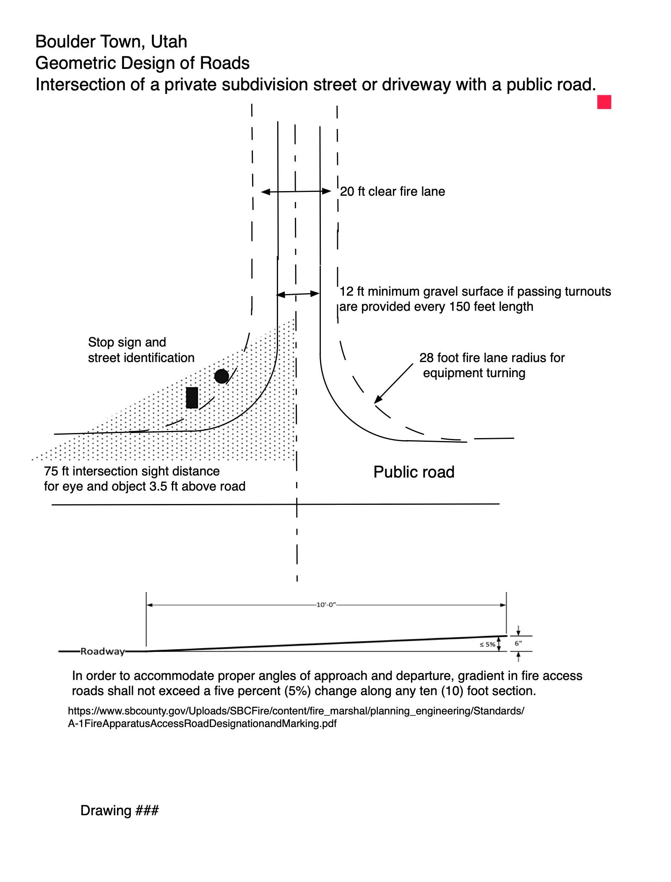

# Section 5 - Guidance for Proposed Maintenance of Private Subdivision Roads

*Authority 152.503*

Identify elements to be included in a Road Maintenance Agreement and/or include a sample of a Road Maintenance Agreement.

* 1. The Road Maintenance Agreement must:
     1. Provide for maintenance of all roads within the subdivision and for the road from the subdivision boundary to the public road.
     2. Be perpetual and run with the land.
     3. Be binding on future property owners.
     4. Require maintaining emergency access meeting the Utah Wildland Urban Interface Code.
     5. Clearly articulate who is responsible for approving and paying for the maintenance work.
     6. Allow the town to repair the road if condition (d) is not met and to file a lien against the subdivision lots to recover repair costs.
  2. Increased traffic due to the subdivision shall not impose increased costs or maintenance obligations on property owners outside the subdivision without their written consent.
  3. Boulder Town encourages a Road Maintenance Agreement that includes all property owners using the road, but subdivision approval is not contingent on parties outside the subdivision signing the agreement.

# Section 6 - Public Safety

*Authority 152.506*

## Fire Protection Plan

### Requirements for Preliminary Subdivision Applications

Written approval of the fire protection plan by the Boulder Fire Authority is a required part of the Preliminary Subdivision Application and the approved conditions and proposed infrastructure shall be documented in the Preliminary Application. Informal discussion with the fire authority early in the development of the subdivision concept is encouraged.

Engineering calculations and construction drawings for firefighting water supply may be prepared after preliminary approval and before final approval of the subdivision.

Building-specific aspects of the fire protection plan shall be approved by the Fire Authority as part of the building permit application process.

### General Requirements

1) The "Authority Having Jurisdiction" (AHJ) is the Fire Authority appointed by Boulder Town. The fire authority will evaluate site conditions and approve fire protection plan for a proposed subdivision based on the following codes:

a) Utah Wildland-Urban Interface Code

b) International Fire Code including Appendices A through D

c) NFPA 1142 Water Supplies for Suburban and Rural Fire Fighting.

d) Refer to the State Fire Marshal website for current editions and any amendments. https://firemarshal.utah.gov/laws-rules/

2) Fire protection plan aspects related to specific structures including sprinklers, fire-resistant materials of construction, building occupancy classification, and maintenance of defensible space are not part of the subdivision review and approval unless the proposed fire protection plan is based on applying fire code exceptions to specific building features or constraints.

3) If the subdivision fire protection plan is based on applying specific fire code exceptions or exemptions based on proposed structures on the property then the applicable building constraints shall be indicated in the Fire Authority approval letter, noted on the plat, and included in a recorded deed restriction that is enforceable by the Town.

### Fire Access Roads

See Section 4 for WUIC all-weather fire lane road design and turnaround requirements.

### Other Requirements

The Fire Authority and fire department members will prepare any additional fire protection plan guidelines.

# Section 7 - Stormwater Drainage, Flood Plains, Sensitive Lands, and Natural Hazards

*Authority 152.507*

## Stormwater Drainage Plan.

### Default Plan – Subdivisions Disturbing Less Than 1 Acre

1) **Applicability** - these default stormwater drainage requirements apply to new subdivisions where the expected disturbed area does not exceed 1 acre including anticipated building footprint and access roads and driveways shown on the plat. This 1-acre disturbance exemption matches the construction permit exemption in the Utah Pollutant Discharge Elimination System (UPDES) which is the permit system mandated by §402 of the Clean Water Act.

2) **Default assumption for disturbed area**. Absent specific construction plans the disturbed area can be assumed to be 0.25 acres per lot.

Example: Assume the footprint of a 3000 square foot house with a 10-foot disturbance around the foundation perimeter plus a 12-foot wide driveway 100 feet long. Disturbed area is about 0.16 acres on the lot. The 0.25 acre default value is a reasonable estimate.

3) **Protection of natural drainage pattern:**  Restoring vegetation after construction, using permeable surfaces on roads and driveways, and avoiding disturbance to existing natural drainage channels are the preferred methods for stormwater management.

4) **Culvert Size**. Culverts are required if private driveways or access roads cross existing drainage channels.

1. Provide culverts where crossing existing natural drainages and roadside ditches.
2. Minor natural drainages may be combined via roadside ditches on uphill side.
3. Minimum culvert diameter 18 inches for drainages handling only on-site rainwater.
4. Minimum culvert diameter 24 inches for drainages handling off-site flows.
5. Minimum compacted fill over culvert 6 inches.
6. Engineered design required for roads crossing Boulder Creek and West Fork of Deer Creek.

5) **Irrigation canals**. Ditch crossings require design approval by the irrigation company.

### Subdivisions Disturbing More Than 1 Acre

1**) Applicability** These requirements apply only to subdivisions proposing to disturb more than one acre. Soil disturbance is described as clearing, grading, or excavating. Normal agricultural activity is not included in the one acre limit.

**2) Engineered Design.** A runoff calculation shall be prepared by a professional engineer. The engineer shall recommend construction-phase stormwater protection, and design permanent runoff controls including culverts and retention ponds in accordance with good practice.

3) **Construction and Industrial Activity.**  The Utah Pollutant Discharge Elimination System (UPDES) permit process is administered by the state and not by Boulder Town.

## Flood Plains and Wetlands

Engineered stormwater management design is required for proposed subdivision development or infrastructure in a mapped floodplain or designated wetland.

1) As of 2024 flood plain mapping has not been done for Boulder Town.

2) As of 2024 Jurisdictional Wetlands under the Clean Water Act have not been determined by the Army Corps of Engineers for Boulder Town.

Interim wetlands guidance: The wetland mapping by Utah Geological Survey is available on the web at <https://wetlands.geology.utah.gov/index.html>. 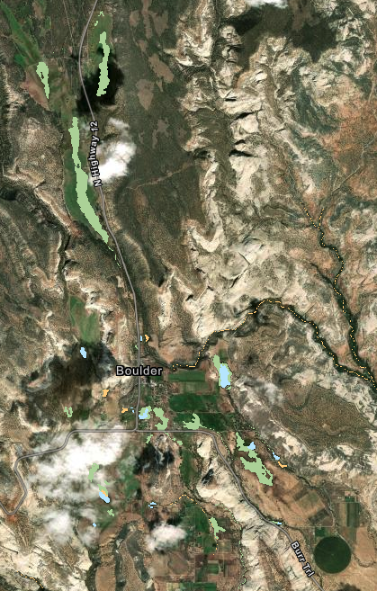

Screen shot of interactive map:

Utah Geological Survey disclaimer: Mapping is conducted primarily by reviewing aerial imagery and cannot be used as the basis for a jurisdictional wetland delineation. This map contains data from NWI that is up-to-date as of June 5, 2024.

## Sensitive Lands

Heading Reserved

See 153.235 through 153.241 of Boulder Town Ordinances

## Natural Hazards

Heading Reserved

# Section 8 - Other Subdivision Development Infrastructure

## Potable Water

Proof of potable water is required. Options are:

1) A binding contract with a public water company regulated by the State of Utah to supply culinary water.

a) An application to Boulder Farmstead is not sufficient; the application must be approved with documented commitment to serve by the water company.

b) The public water company approval for a new hookup must remain valid for at least two years to allow for infrastructure construction and final recording of the plat.

2) An underground water right granted by the State of Utah to drill a well.

a) State approval of the well application is sufficient.

b) Drilling the well and proving the water right can take place after subdivision recording. Prompt development of the water right is prudent because the water appropriation approval from the state is for a limited time and rules for a watershed can change.

## Wastewater Disposal

1) Septic systems are regulated by Southwest Utah Public Health Department.

2) Each proposed lot requires a perc test in at least one location on the lot.

3) The perc test and approval may take place after Preliminary subdivision approval and before final approval.

4) Non-buildable lots do not require septic approval provided the restriction on dwelling construction is noted on the plat and in a recorded deed restriction.

5) Alternative waste water disposal systems shall be allowed if:

a) The system is designed by a qualified professional.

b) The system is approved by Southwest Public Health or by the Utah Department of Environmental Quality.

## Electricity

Off-grid solar power is permitted.

## Communications

Boulder has no requirements for phone or internet connection in subdivisions.

## Irrigation Infrastructure

### Subdivision Application Requirements

1) Notice shall be provided to Boulder Irrigation Company or to the owner of any private irrigation infrastructure.

2) A "no objection" letter from the irrigation company should be provided with the Preliminary Application.

### Irrigation In or Crossing Subdivision

1) Location of all known irrigation infrastructure shall be shown on the subdivision plat.

2) Written approval of the owner is required if the subdivision plat or development plan indicates that the subdivision disturbs or alters existing irrigation infrastructure.

3) Recommended good practice is that the plat indicate a 30-feet wide access easement (15 feet on each side of centerline) for irrigation company maintenance of existing canals, ditches, and pipelines within the subdivision.

### Assumptions for Plat Review

1) All existing irrigation ponds, canals, ditches, diversion structures, and pipelines are private property owned either by the Boulder Irrigation Company or by downstream water users.

2) Existing irrigation structures may have an easement created by historic use even if the easement has not been recorded.

3) The ALUA will not approve a subdivision that interferes with existing property rights. Good faith negotiation between the developer and the irrigation company is encouraged, but is regarded as a private matter by the Town.

### Roads Crossing Irrigation Canals or Ditches

1) A metal or plastic culvert shall be provided where the road crosses any canal.

2) Culvert diameter shall be 36 inches or as determined by the irrigation company.

3) Compacted road base thickness over the culvert shall be 12 inches or as specified on the culvert manufacturer's design table.

4) Stone riprap or a concrete headwall and wingwalls shall be provided on the upstream side.

# Section 9 - Open Space & Agricultural Protection

*Authority: 152.601(C)*

## Non-Buildable Lots associated with Lot Averaging

Minimum Requirements for ALUA approval of proposed number of lots:

1) The plat shall clearly indicate all non-buildable lots.

2) The restrictive covenants related to the non-buildable lots shall be documented with the county recorder before or concurrent with recording of the plat.

3) The covenants shall prohibit construction of any dwelling or accessory building.

4) The building restriction shall be perpetual.

5) The building restriction shall be enforceable by Boulder Town.

6) The covenants shall identify the person or entity responsible for management of the non-buildable lot and the process for transferring responsibility in the future.

a) A statement that the lot shall be managed by the owner of record of a lot is sufficient.

b) Management of a restricted lot by a Homeowner’s Association meeting UCA 57-8a is sufficient.

# Section 10 - Quantitative Engineering Design Criteria

The following Boulder-specific design criteria are provided for reference by citizens, design professionals, and the administrative land use authority in preparing and reviewing subdivision infrastructure proposals.

These criteria reflect past Boulder practice and may be less restrictive than criteria used in other jurisdictions or criteria found in codes that have not been formally adopted by the Town.

## Garfield County Climatic and Geographic Design Criteria

See County Building Department website for updates.

<https://www.garfield.utah.gov/home/showpublisheddocument/2212/638161334313400000>

## Drainage

### Rainfall

Point precipitation frequency estimates for Boulder, UT taken from the NOAA website.

| Duration | 10-year | 25-year | 50-year | 100-year |
| --- | --- | --- | --- | --- |
| 1-hour | 0.87 inches | 1.15 inches | 1.40 inches | 1.69 inches |
| 24-hour | 1.99 inches | 2.44 inches | 2.80 inches | 3.18 inches |
|  |  |  |  |  |

Note: These values are for 300 North and Highway 12. Precipitation is much higher at the north end of town closer to Boulder Mountain.

### Drainage criteria for subdivision roads

The design criterion for private roads in small subdivisions is that the driving surface should not wash out during a 25-year storm event. Minor, temporary flooding of a paved or hardened swale is consistent with the rural character of Boulder.

Subdivision roads crossing existing drainage channels shall not cause the runoff from a 25-year design storm to leave the existing channel and flood adjacent property.

## Local Traffic Data

Current Boulder Traffic

ADT data for 2020 (Jones & Demille, 2022)

Highway 12: 760 Vehicles per day

Burr Trail: 540 Vehicles per day

Rule of Thumb Capacity Guidance

( source website MikeOnTraffic.com)

Single family house: 10 trips per day, 1 per peak hour.

Planning level for local 2-lane street based on livability: 1000 vehicles per day

Capacity for 2-lane major highway with left turn lanes: 18,300 vehicles per day.

Traffic Design

Consistent with the rural character of Boulder new subdivision roads should be designed as informal "country lanes" with low design speed.

## Quantitative Road Design Attributes

The following design criteria are descriptive of past practice in Boulder. Values are based on the Utah Wildland-Urban interface code, and the rural road standards from other jurisdictions.

| **Design Attribute** | **Driveway** | **Private Subdivision Road** | **Road intended to be dedicated to the town** | **Note** |
| --- | --- | --- | --- | --- |
| Lots accessed | 1 lot Maximum  Max 2 buildings not including accessory structures | 1 to 25 | Unlimited |  |
| Design speed | NA | set by owners  15 mph default | 25 mph |  |
| Lanes | 1 | 1 with passing turnouts | 2 |  |
| Lane width - driving surface | 10 ft | 12 ft | 20 ft |  |
| Shoulder | 5 ft | 4 ft | 4 ft |  |
| Width clear for emergency vehicles | 20 ft | 20 ft | 32 ft | WUIC minimum 20 ft |
| Vertical Clearance | 13 ft 6 inches | 13 ft 6 inches | 16 ft | WUIC  13'-6" |
| Passing turnout interval | 200 ft | 200 ft | NA |  |
| Passing turnout length | 30 ft | 30 ft | NA |  |
| Passing turnout width | 8 ft | 8 ft | NA |  |
| Dead-end turnaround | Per Fire Code | Per Fire Code | Per Fire Code | WUIC and IFC |
| Recorded right of way width | NA | 40 ft | 66 ft |  |
| Cross Slope | NA | 3% | 3% |  |
| Radius of curvature | NA | 100 ft or right angle intersection | 200 ft or right angle intersection |  |