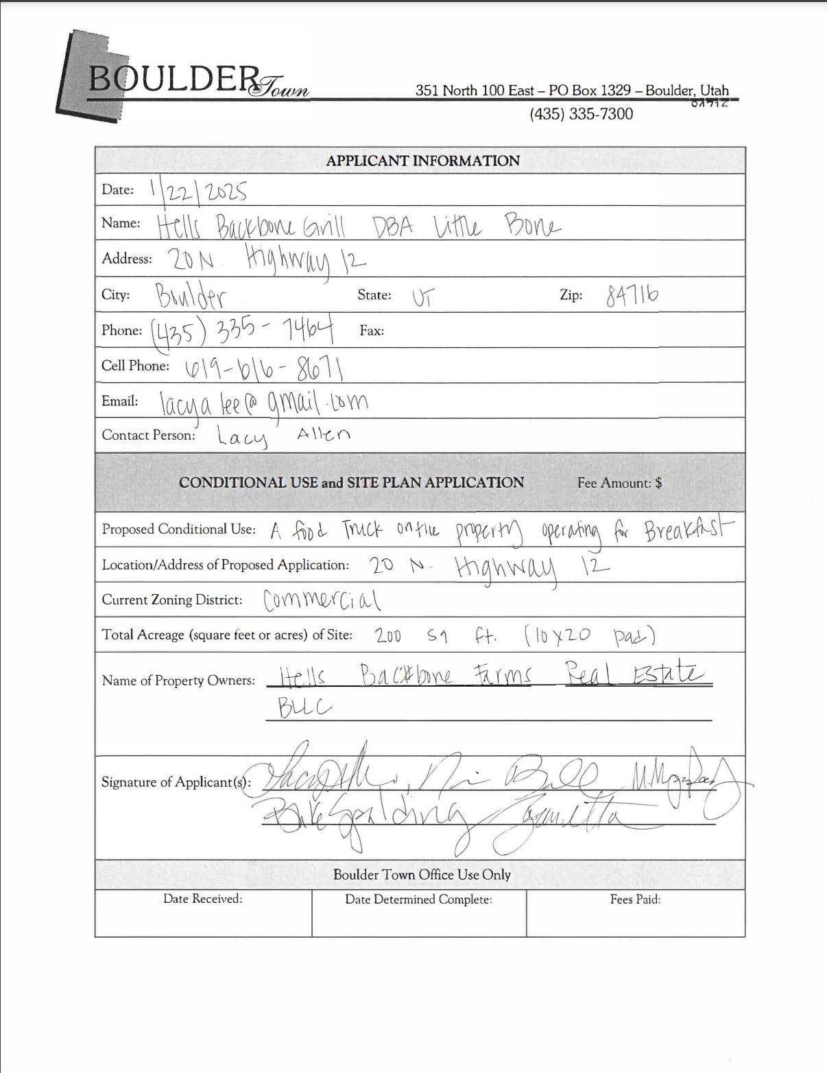

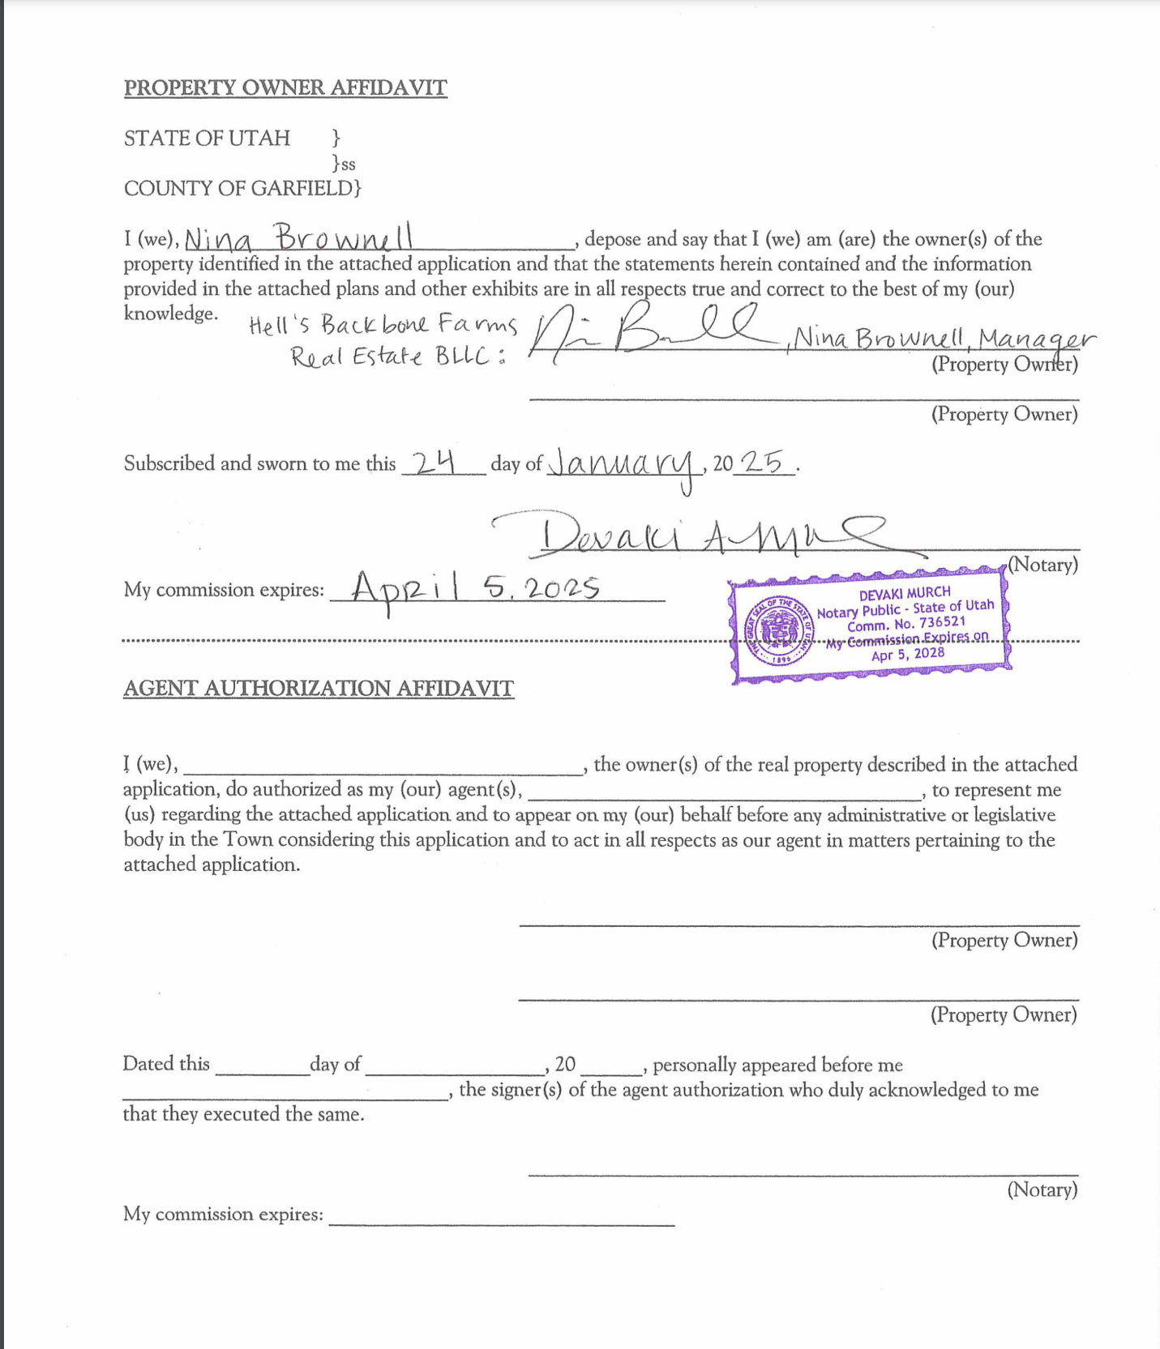

§ 153.152 (2): Proof of Ownership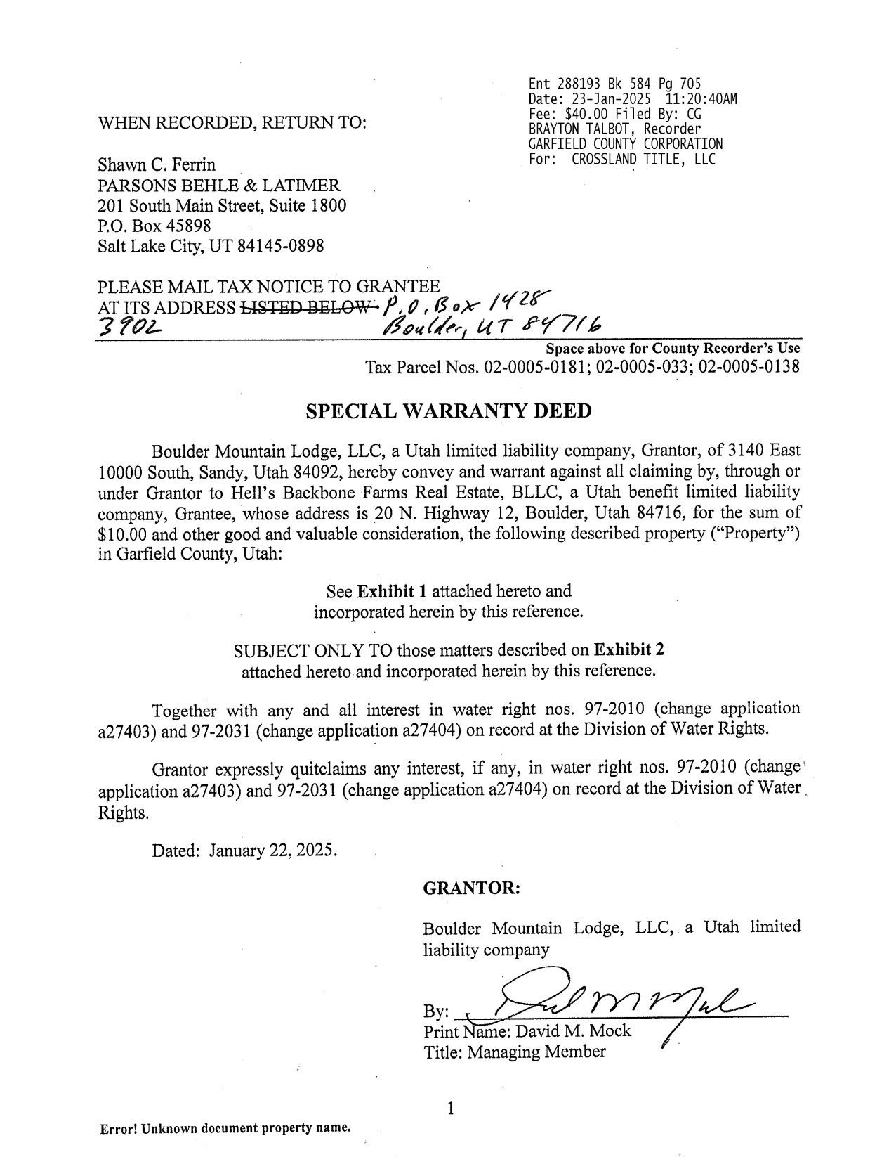

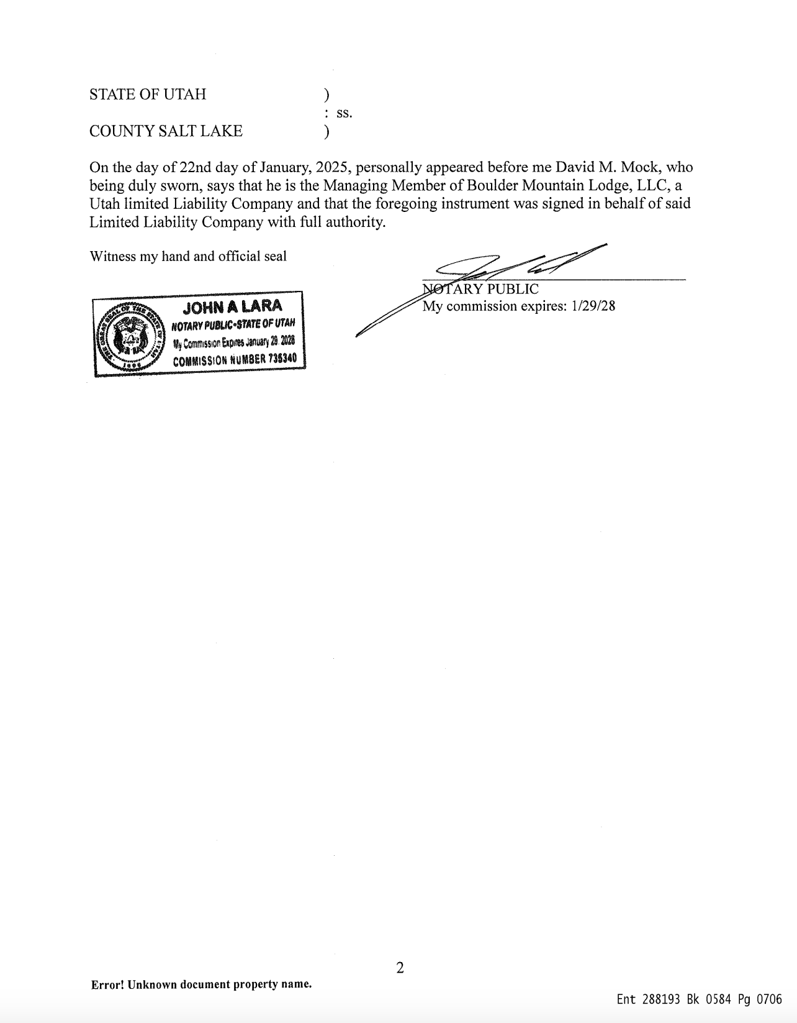

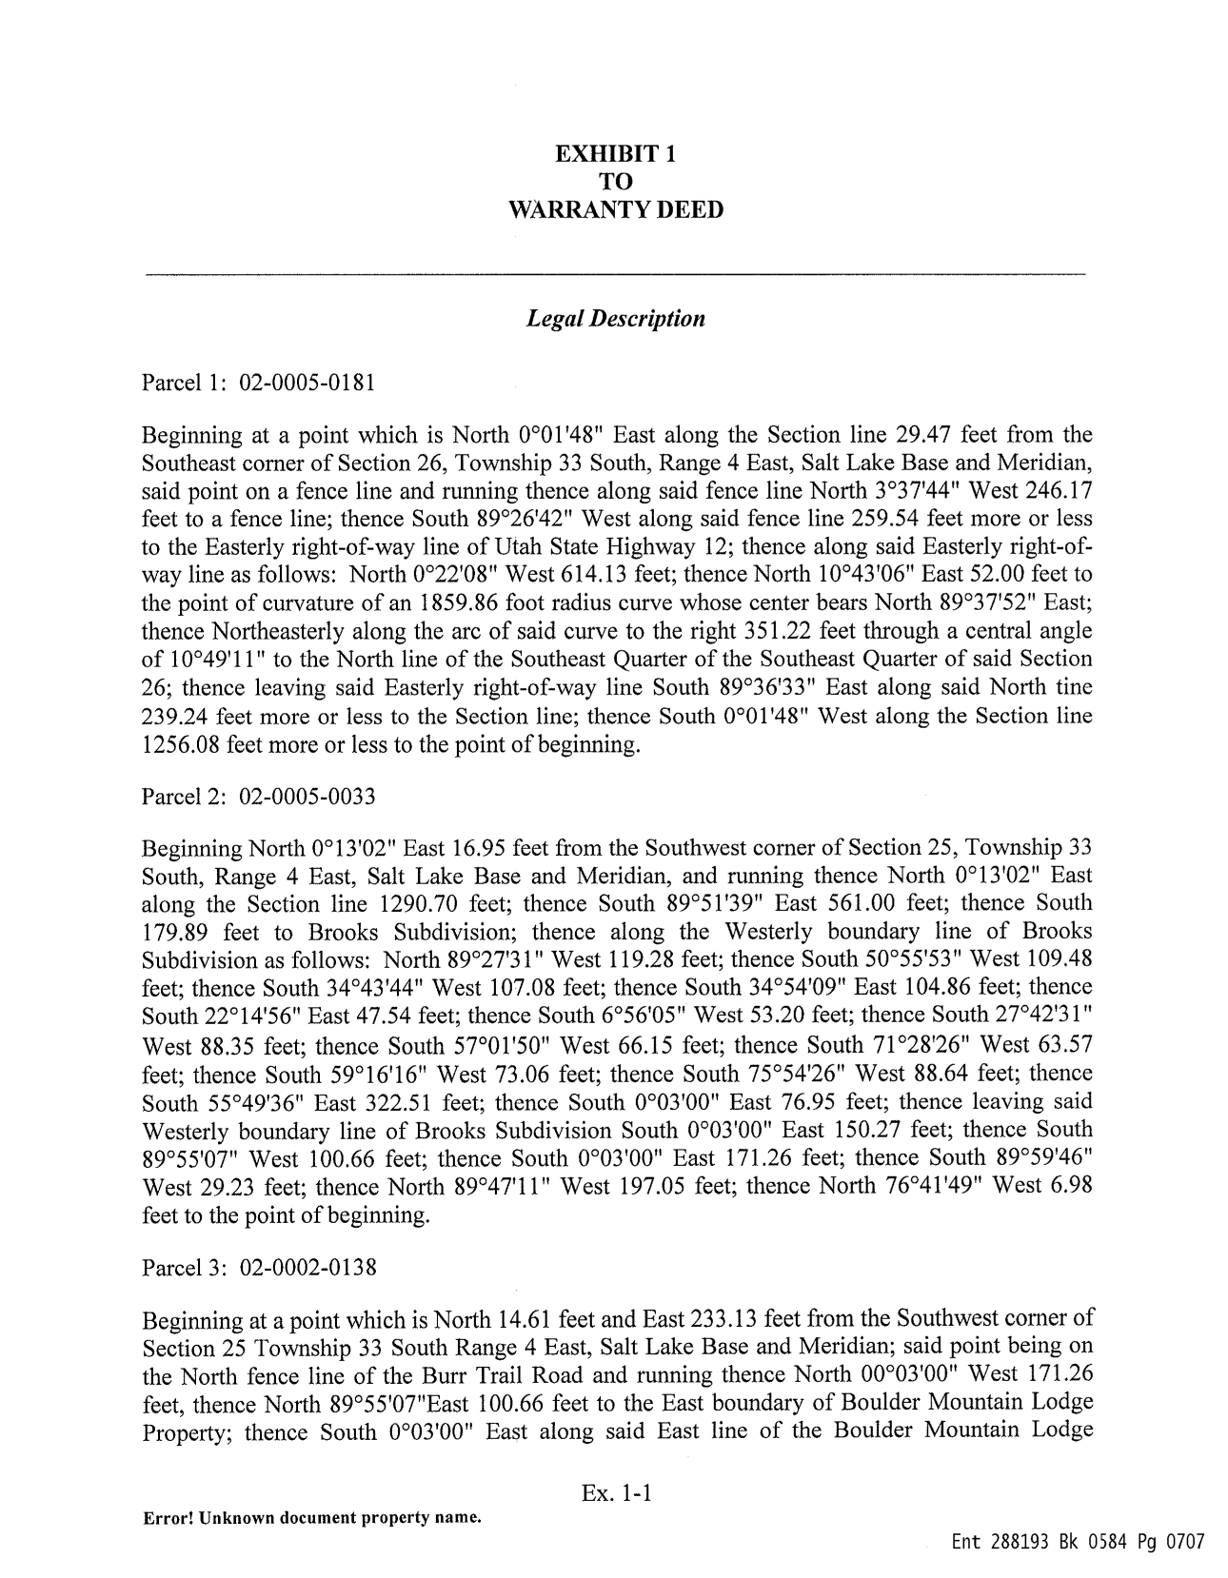

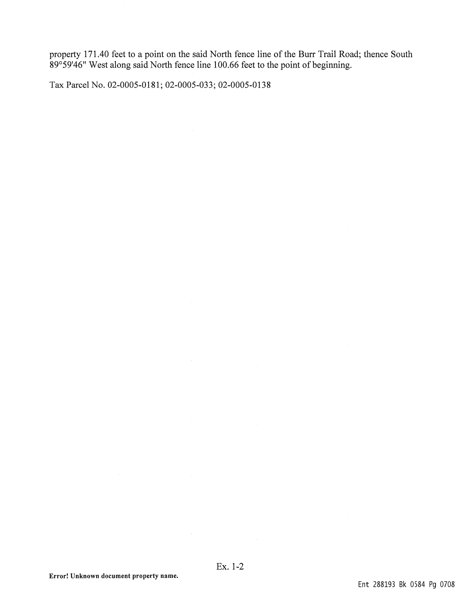

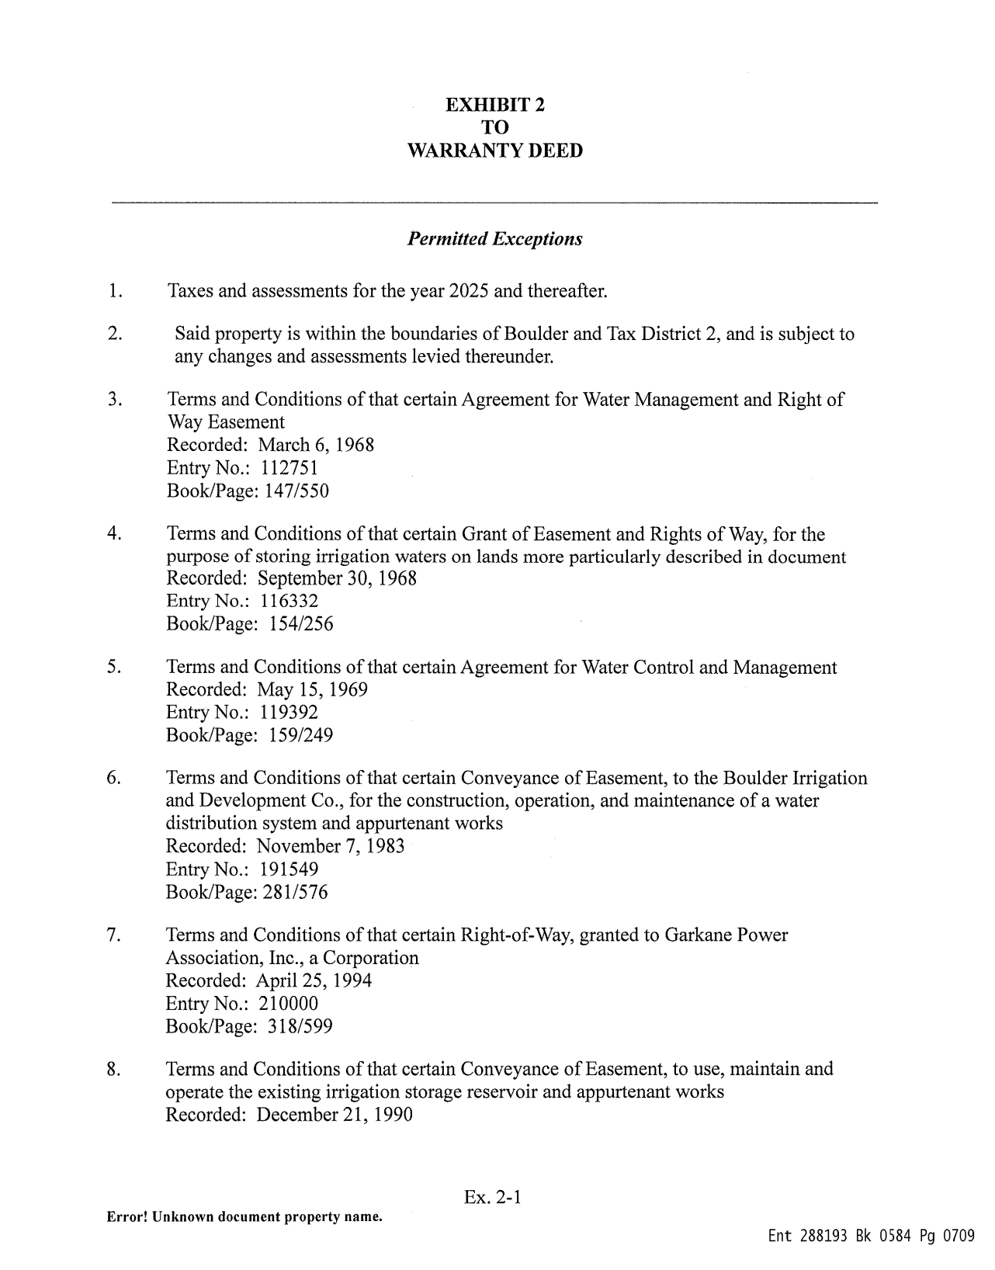

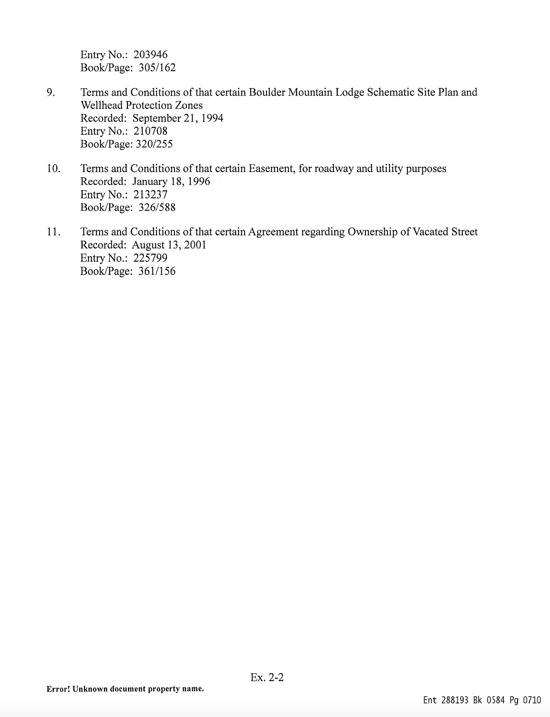

Site Development Plan:
§ 153.152 (A)
§ 153.152 (B)(1)
§ 153.152 (B)(3)
§ 153.152 (B)(4)

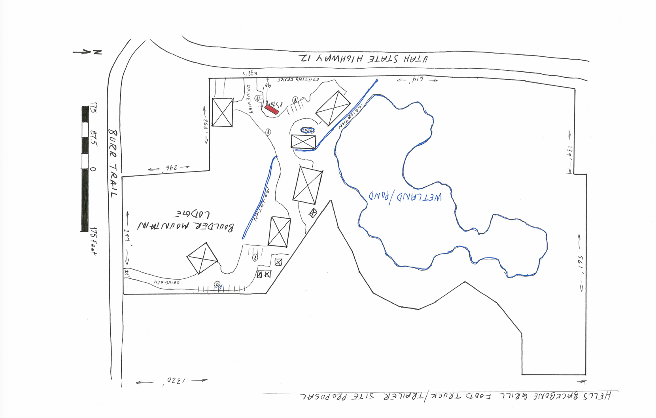

§ 153.152 (B)(5)

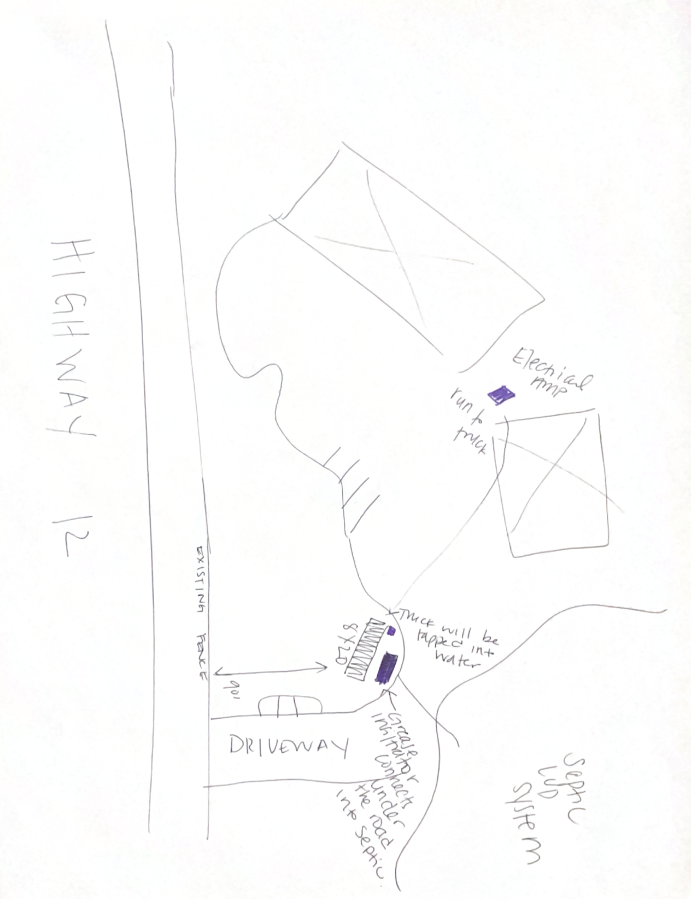
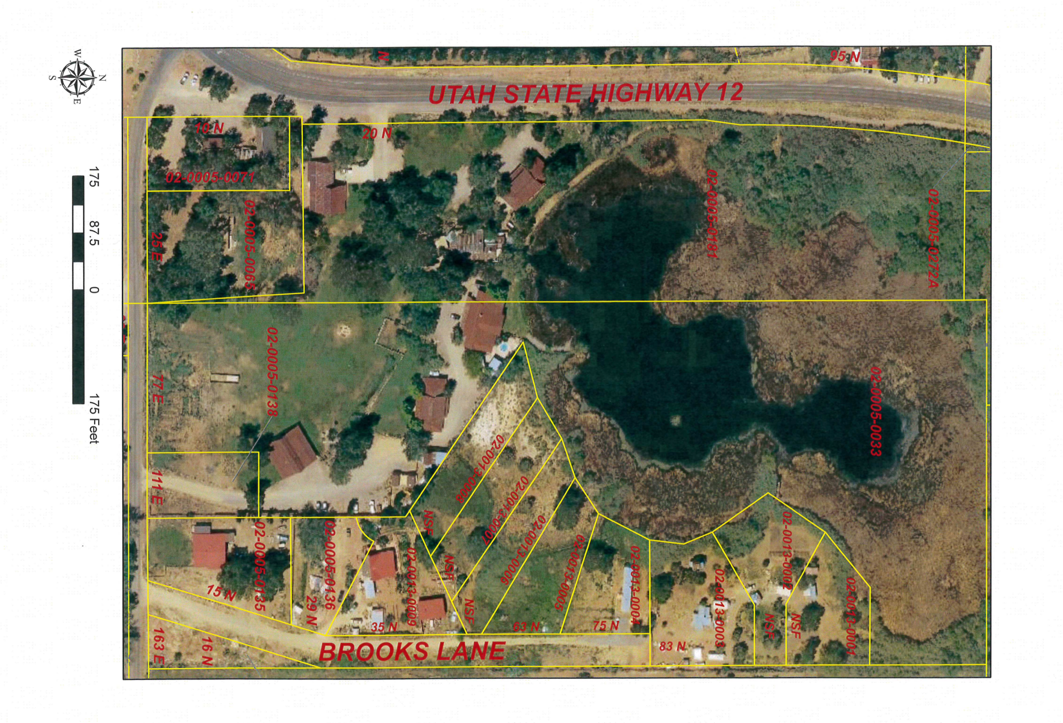
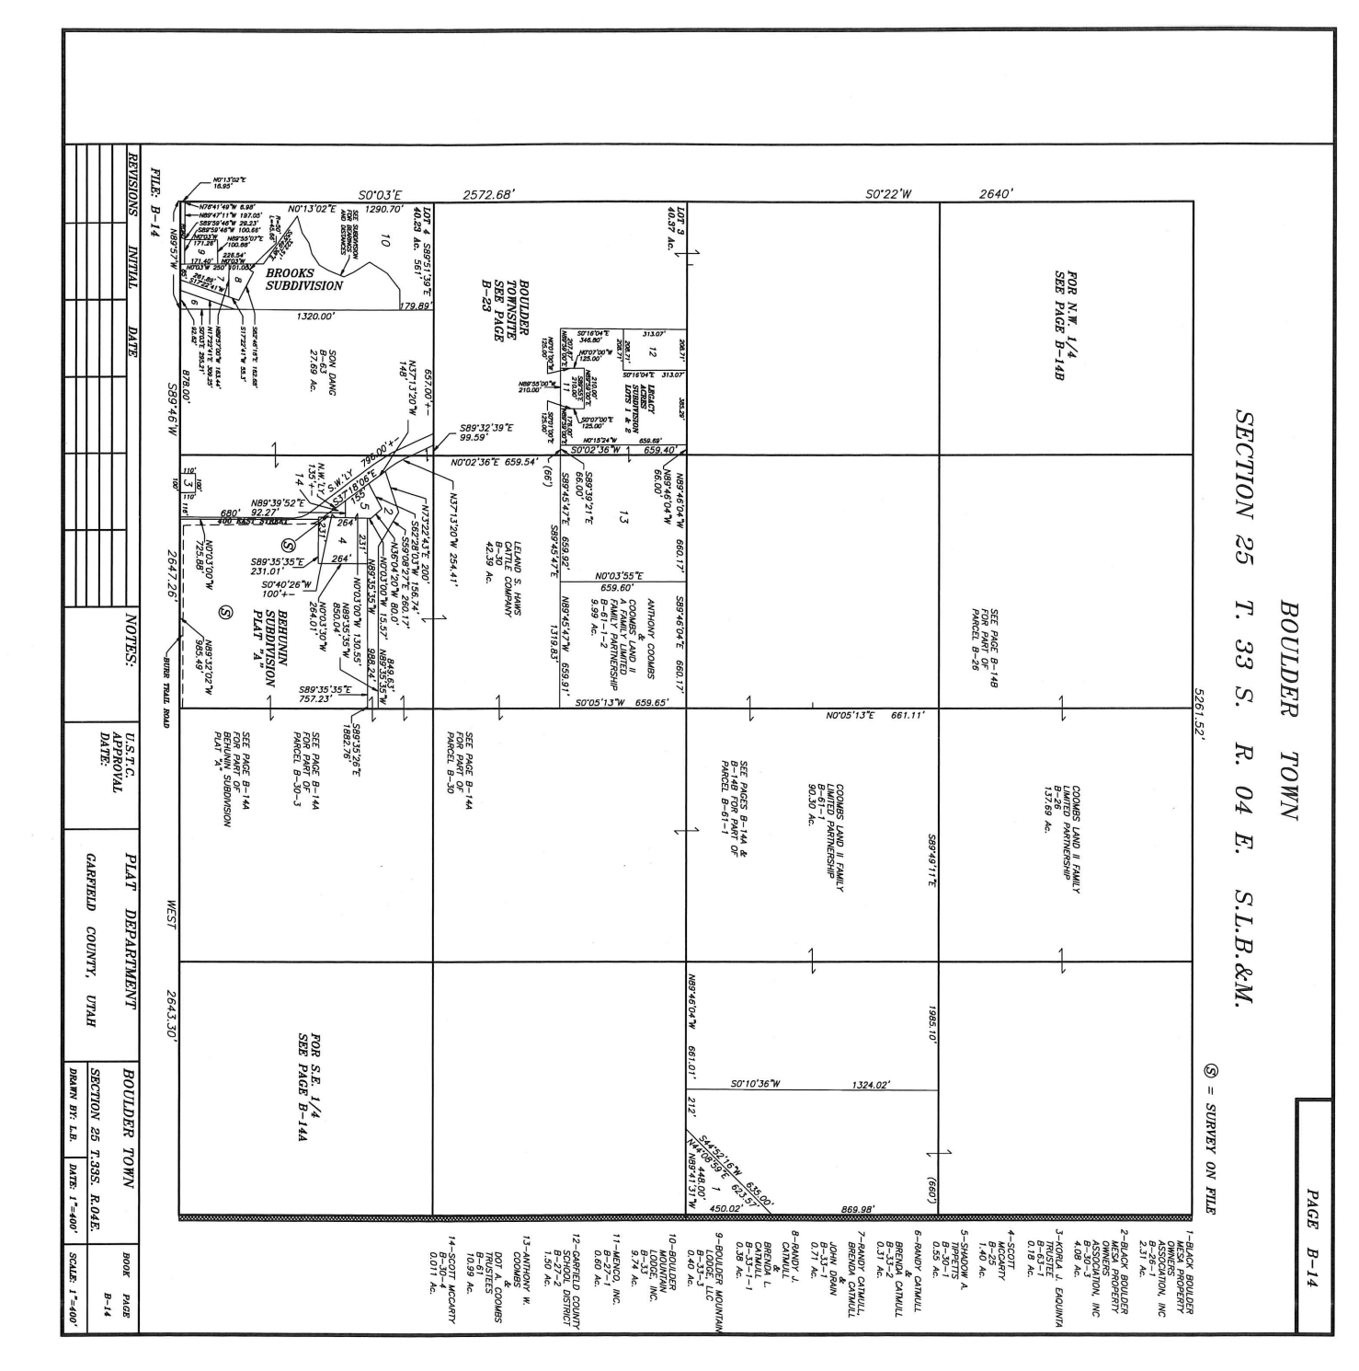

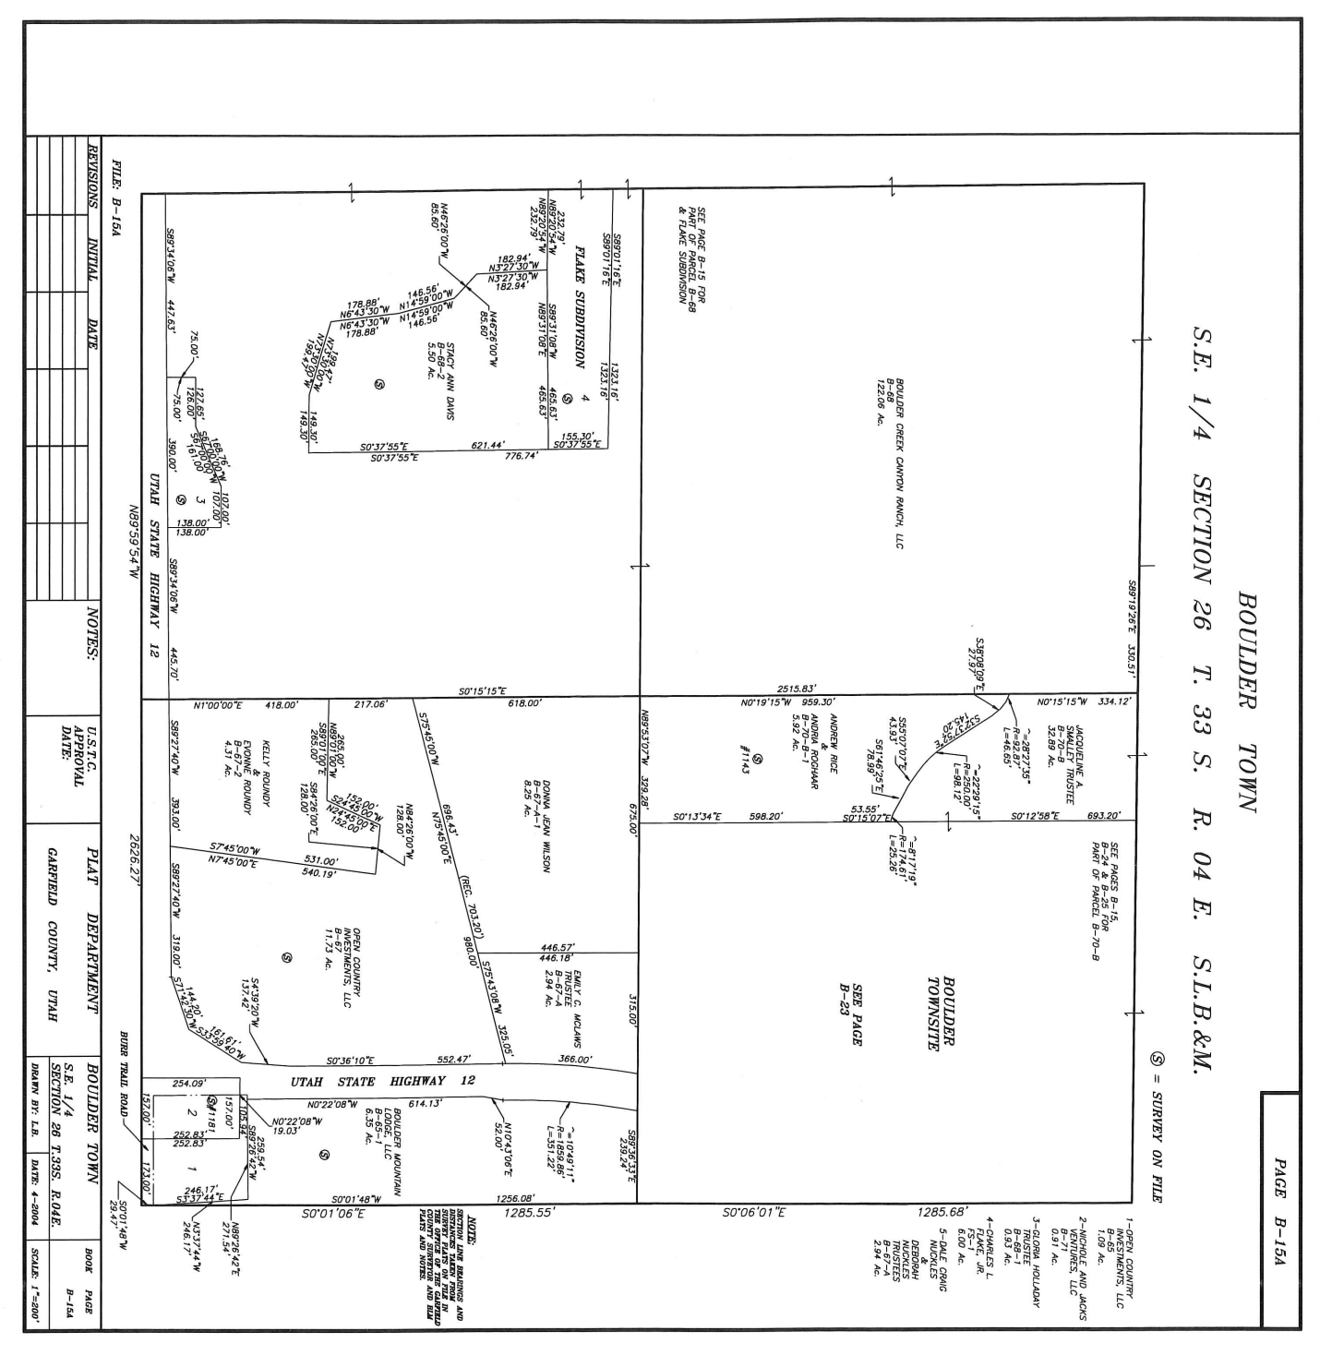

§ 153.152 (B)(6)
Storm Water Plan
The food truck will be located on a 10X20 gravel pad surrounded by grass. Any storm runoff would be absorbed by the surrounding grassy area.

§ 153.152 (B)(7)
Landscape Plan
The plan is to lay down a 10X20 that is 3 inches deep gravel pad on the existing grass area surrounded by existing trees. There would be no treatments or changes to the vegetation in the existing area other than the gravel pad where the food truck will be set on.

§ 153.152 (B)(8)
Construction Plan
Phase 1 - Install Grease Interceptor below ground that goes from the food truck and ties in directly to the septic system which is a requirement from the Southwest Department of Health. Electrician to install new 100 amp electrical service connection for the Food Truck.

Phase 2 - Lay down 3” deep gravel to serve as a pad for the Food Truck. Design an improved parking area for the Food Truck and Hells Backbone Grill.

Phase 3 - Bring the Food Truck to the pad, hook up the truck into the septic, plumb into water and electrical.

Permits necessary are the CUP from Boulder Town and the operation license from the Southwest Department of Public Health.

§ 153.152 (B)(9)
Service Impact Assessment
The food truck requires water and will be plumbed into the well water system on site. Connect to the electrical service connection and connect to the septic system.
Traffic is presumed to be primarily guests who are staying on the property plus locals and tourists. Volumes will be considerably less than Hell’s Backbone Grill sees during dinner service hours. Access is directly off of Highway 12 as there is an entrance where the food truck will be located. There will be an improved parking area with more parking spaces.

We plan to meet the requirements for waste disposal by bagging up all waste and depositing it into appropriate garbage bins to ensure proper disposal.

There are no permits applicable to this project from the Department of Transportation.

§ 153.152 (B)(10)
Building Plans and Signs
The food truck will be a trailer that will have a colored vinyl that will coincide with the colors of the natural surrounding areas and Hell’s Backbone Grill. There are requirements to have 4” letters on the truck with the name of the business “The Little Bone”. That is required through the Southwest Department of Public Health which does not interfere with the Boulder Town Sign Ordinance. The property that was acquired by Hell’s Backbone Farms Real Estate will be updated and signage will comply with the Ordinance once that is finalized. There will be a small sign at the truck that is movable until that time.

§ 153.152 (B)(11)
Additional items related to operating a food truck:
- Managing waste: Grease Interceptor will be installed below ground and will tie into the existing septic system. Takeaway containers will be available, however food will be served on dishes to limit the amount of garbage.

